Vera Tanner

George Dupre Crozier MURRELL *31.12.1894
(Served with Duke of Edinburgh's Own in S.W.Africa and the Rifle Brigade in France. Wounded at the Somme during WW1)
x- 1930 Vera TANNER *1906
Daughter: Julia de Burley MURRELL *14.7.1934
x1- Allan SANDERSON
x2- Terry STEVENS
Grandchildren : Ingrid SANDERSON *1957 Michael SANDERSON *1959 Sarah SANDERSON *c.1965
Paris 1924 - Swimming, women's 4x100m freestyle (SILVER)
Amsterdam 1928 - Swimming, women's 4x100m freestyle (SILVER)
Vera Tanner's story extends far beyond the swimming pool.
The Eastbourne-based swimmer made her Olympic bow in Paris, part of the British 4x100m freestyle team who won silver behind the USA in a time of five minutes and 17 seconds.
Four years later Tanner repeated the feat and added a second Olympic silver to her CV, in a time that was 15 seconds faster.
Just one year after losing in Paris, the Brit was part of Gertrude Ederle's (USA gold medallist from 1924) first attempt at swimming the English Channel in 1925.
Ederle was unsuccessful in that attempt but the historic first is still embedded in swimming lore - with Tanner on the boat for support.
In fact, Tanner's love for teaching and swimming extended to her day job too, eventually settling down as a teacher in Grahamstown, South Africa after touring the country with the GB ladies team in 1929.
Tanner retired from competitive swimming in 1934 and in the late 1930s, the two-time Olympic medallist moved again to work in the Hong Kong Education Department, but that all soon changed as war broke out in 1939 and she enrolled as a nurse in the Auxiliary Nursing Service.
Our hero's story takes a turn from here. Working in the ANS, Tanner consequently missed the compulsory evacuation of women and children from Hong Kong in July 1940 and became a Japanese prisoner-of-war, interned at Stanley Internment Camp.
Scanning the list of internees at the Camp shows that Tanner was allocated Camp No. 2223 and her billet was Block 10 room T5, sharing a room with Miss Elma Kelly, an Australian journalist and Mrs Maud Minhinnick, the wife of a Naval Officer.
But even as a prisoner-of-war, her love for swimming and teaching never faded.
The Team GB athlete took to the water at Tweed Bay Beach in Hong Kong as both a lifeguard and to give swimming lessons to the other internees when they were allowed to during the summer months.
And in true Tanner fashion, when Hong Kong was liberated in 1945, a Dundee Evening Post article credits the Brit with one final swimming story that is nothing but inspirational:
"When rescue came in the shape of an allied minesweeper, she was so overjoyed that she swam a mile and a half out to it.
"Thin and half-starved as she was, she made the journey in 30 minutes."

Vera Murrell - Olympic Games Swimmer and Prisoner of War

https://battleforhongkong.blogspot.com/2014/07/vera-murrell-olympic-games-swimmer-and.html

On Sunday 7 December 1941, Captain Peter Belton who was on the staff of Brigadier Cedric Wallis, commanding officer of the Mainland Infantry Brigade, packed his bags and moved into the Brigadier's flat in Argyle Street to be close at hand to his boss and the other members of the brigade staff. During that weekend there had been an increase in tension and a heightened alert. A state of emergency was declared that Sunday because Japanese forces were observed in strength just across the border. The Hong Kong Volunteer Defence Corp (HKVDC) had been mobilized earlier that day. The Mainland Infantry consisting primarily of 2nd Battalion Royal Scots, 5th Battalion of the 7th Rajput Regiment and 2nd Battalion of the 14th Punjab Regiment had been at their battle stations on the Gin Drinkers Line (GDL) since the middle of November. This line of pillboxes, trenches, barbed wire entanglements and minefields ran east-west across the Kowloon peninsula, from Port Shelter and Tidal Cove in the east to the rather strangely named Gin Drinkers Bay in the west. The Royal Scots were deployed in the malarial effected area on the left flank and were below strength because of the number of malaria cases affecting the men. The Rajputs controlled the right flank and the Punjab Regiment held the centre. The defensive line followed the line of hills, keeping where possible to the high ground. Across the border, the 38th Division of the Imperial Japanese Army who had brutalized their way through China were now preparing to invade this outpost of empire and to bring down a reign of terror that would last for nearly three and half years.
In Captain Belton's handwritten war diary for Sunday 7 December, he writes:
Decided to stay that night at the Brigadier's flat in Argyle Street. Put all my personal belongings in the hot-room and completed my own kit down to details such as hip flask of rum. Had quick dinner. James came in with Ned Curran and Vera Murrell, had a drink with them. Vera amused by my preparations - Ned laid a wager that this time it was 'the real McCoy'. (1)
Ned Curran won that wager. At 0545 hours the next morning, the Brigadier was informed by telephone from China Command Headquarters that war with Japan was imminent. A short while later the General Officer in Command (GOC), Major-General Christopher Michael Maltby, known as Mike, phoned with the message that 'we are at war with Japan'. The brigade staff moved to their temporary Battle HQ at Jubilee Buildings, Sham Shui Po Barracks.
Just before 0800 hours a message came in from 2nd Bn. Royal Scots that twenty-seven enemy aircraft had passed overhead flying towards Hong Kong. A short while later Kai Tak airport and Sham Shui Po Barracks were subjected to a massive air raid. Jubilee Buildings received several direct hits with other bombs falling on the barracks but casualties were light as most troops including the two Canadian battalions had already moved to their battle stations.
Let us return once more to that hurried dinner on Sunday night on the eve of battle. Without a surname I can not identify James, but what about Ned Curran and Vera Murrell. A quick search of the garrison list (2) showed that Ned was Major Edward J. Curran of the Royal Army Medical Corp (RAMC). He was a Hygiene Specialist and was Officer in Command Hong Kong Field Hygiene Section, RAMC. He was specialized in malaria and malaria prevention which at that time was a serious problem affecting troops manning the GDL. I found a reference to him in Lt Colonel Cedric Shackleton's war diary. Lt Col. Shackleton, RAMC, was Commanding Officer of the Bowen Road Military Hospital
Major E J Curran and two Staff Sgts of RAMC together with 14 Chinese ORs of the Hong Kong Field Hygiene Section reported at the hospital and were accommodated. The Chinese personnel were more of an encumbrance than anything else, spending most of their time in the air raid shelters, until their final desertion on 24 December." (3)
On 28 Dec 1941 after capitulation - Medical Officers were detailed as follows to take charge of troops collected at the places shown: Captain Reid, RCAMC, to Victoria Barracks - Captain Coombes, RAMC, to Battle HQ and vicinity - Major Curran, RAMC, to Murray Barracks - Lt Lancaster, RAMC to Wellington Barracks. (4)
Who I wondered was Vera. A search of the list of internees at Stanley Internment Camp, held at the Imperial War Museum in London, revealed that she was Mrs Vera Murrell. She had been allocated Camp No. 2223. She was born 20 November 1906 making her 35 years old at the time she was incarcerated in a Japanese concentration camp. Her occupation was described as a Teacher and her billet was Block 10 room T5. This block was situated near St Stephens College and away from the Prison Wardens Quarters where many of the other internees were billeted. She shared a room with Miss Elma Kelly an Australian journalist and Mrs Maud Minhinnick the wife of a Naval Officer.
She avoided compulsory evacuation of women and children in 1940 because she had enrolled as a nurse in the Auxiliary Nursing Service (ANS). After the capitulation on 25 December 1941 and before incarceration at Stanley Internment Camp she was held at the HK University Relief Hospital (5). We can assume that she was working in the University Relief Hospital from the outset of hostilities on Monday 8 December, which was the day after that dinner with Captain Belton and Major Ned Curran.
I had seen a reference to Vera in Barbara Anslow's (nee Redwood's) diary of her experiences in Stanley Camp for 24 Dec 1943.
Draw for two 10 lb iced cakes made by Father B. Meyer. Won by Mrs. V. Murrell and Mrs. B. Doering. Air raid during proceedings. (6)
A further reference to Vera was found in the Colonial Secretary's (Franklin Gimson's) diary.
I saw Mrs Murrell and asked her to take responsibility for life saving on Tweed Bay Beach. (7)
Another reference was to the effect that she had signed off on a life-saving certificate issued to Herbert William Johnston in July 1943 at Tweed Bay Beach. Tweed Bay Beach was once a popular swimming beach, now deserted and difficult to access, but during internment the Japanese allowed internees to swim there during the summer months.
The photograph below shows Tweed Bay beach as it looks today. It was here that one of the internees was killed by a shark only days after liberation in September 1945. It was here that Vera a strong swimmer gave lessons in swimming and lifesaving to other internees. It was here that three-year-old Brian Gill drowned in a freshwater pool near the beach in May 1944, and I assume it was in response to this that Franklin Gimson officially asked Vera to take responsibility for lifesaving on the beach.

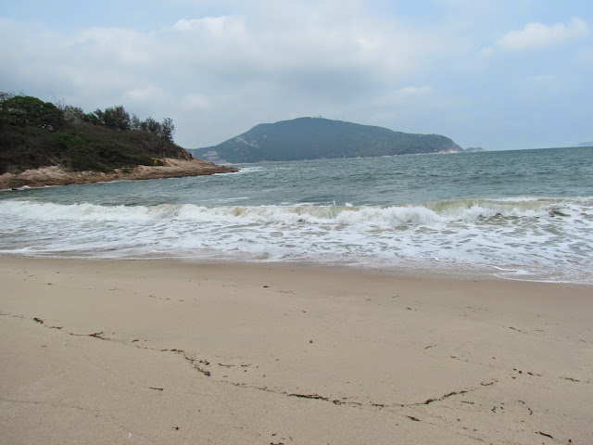
Tweed Bay Beach used by the internees
The prison walls dominate the beach.

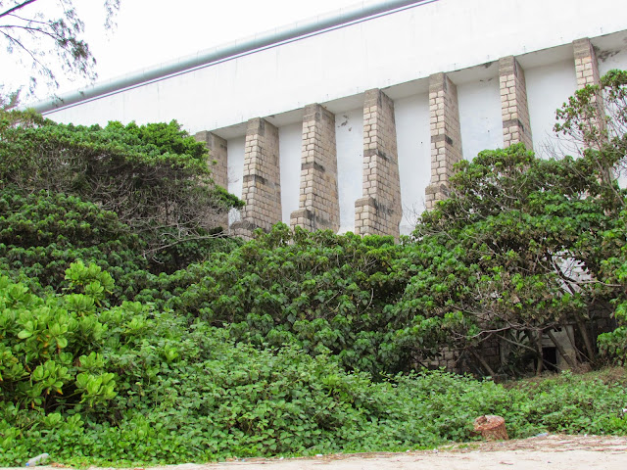
The Prison walls behind the beach
A search of Ancestry.com led me to Marianne Sanderson a family member who has been researching her family history and from whom I learnt much more about Vera's life. She was born Iris Vera Tanner and became quite famous in her twenties as an Olympic swimmer. She represented Great Britain at the Olympic games in Paris (1924) and again in Amsterdam (1928) winning the silver medal at both Olympic Games. In the photograph below Vera is third from the left in the front row.

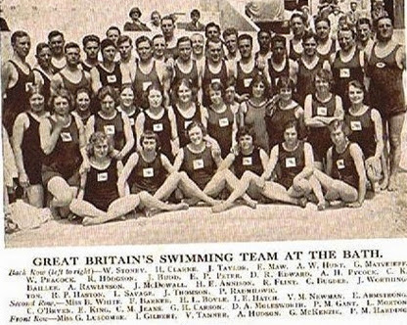
Vera Olympic Games Swimmer (Courtesy Marianne Sanderson)
Vera met her first husband George Dupre Crozier Murrell at the 1928 Olympic Games. He had accompanied the South African swimming team. They married two years later in April 1930. They had one daughter Julia. George Murrell had served as a soldier with distinction in the Great War. (8) He was wounded at the Battle of the Somme in July 1916 in no-mans land between the British and German lines. His hip was shattered, but he managed to crawl back to British lines a feat which took him three days and accomplished at night under the cover of darkness. (8)
Vera lived in South Africa from 1929 until 1939. Kobus Scheepers who is researching swimming history in South Africa informed me that she was employed as the swimming teacher at St Andrew's Prep School in Grahamstown during this period (1929-1939) and was remembered as such in the school newsletter (Old Preppies) in April 2013. George Dupre Murrell was a master at St Andrews School. He had been a competitive swimmer before WW1 and had taught at St Andrew's since the end of WW1. The marriage was not to last, they separated and later divorced. Vera travelled out alone to Hong Kong where she was employed as a teacher with the Hong Kong Government Education Dept. (8) I subsequently learnt from Hong Kong historian Tony Banham that she had been a School Mistress at King's College, established in 1926, teaching English. She was appointed to this role in 1939.

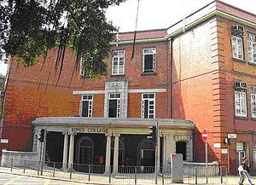
Kings College (Source: Wikipedia)
The building was badly damaged during the war mainly as a result of looting. For a time it was occupied by the Japanese Army who kept mules there. It was rebuilt after the war. The Principal in 1941 was Harold Wallington who with his wife Constance was incacerated together with Vera at Stanley Camp. Harold and Constance Wallington were in Block 2 Room 4. Two other colleagues of Vera who had joined the HKVDC were incarcerated in Shamshuipo Camp, these were Gordon Patrick Ferguson who after the war taught at Central British School (CBS) and James Johnson Ferguson who returned to King's College after the war. Another colleague Geoffrey Coxhead had taught at King's College but had left to join the teaching staff at CBS. He was incarcerated in Shamshuipo POW Camp. There were two other school mistresses at Kings College who were incarcerated at Stanley these were Margaret McGuffog (Block 2 Room 17) and Eleanor Beavis (Block 4 Room 19). They were both nurses with the Nursing Detachment (ND) of the HKVDC.
Clearly, Vera must have fallen in love with Ned Curran, the dashing Army Officer, with whom she had dinner on that last night before war erupted. They were not, however, to see each other again for more than three-and-half years. The following day war broke out and they went to their respective war stations. After the capitulation, Ned Curran was interned in military POW Camps in Hong Kong until shipped to Japan in April 1944 as part of the 6th draft of prisoners of war despatched to Japan. He sailed on the Nauru Maru arriving in May 1944. Most of this draft were sent to Sendai Camp where they worked in the Yoshima Coal Mine (9). The conditions in the military POW camps were appalling. Men were on starvation diets, weak and emaciated. Medicine was scarce and many died from illness and malnutrition. It was hard just staying alive.
For Vera, the Civilian Internment Camp at Stanley was not much easier. The food rations were woefully inadequate and there were many cases of malnutrition and early deaths. Some POWs and internees who had friends outside benefited from receiving food parcels. Those with money or things to sell could purchase food on the black market, but for many who did not receive parcels and had little money they had to rely on the standard rations - two meals a day, very often just a small bowl of rice and watery vegetables. The photograph below shows emaciated internees at Stanley Internment Camp standing outside Tweed Bay Hospital.

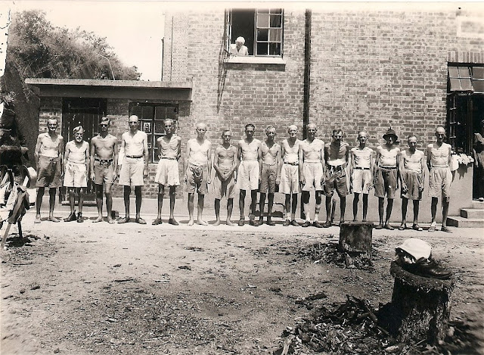
Emaciated internees at Tweed Bay Hospital Stanley Camp
Liberation came in August 1945. On the 30 August, the British Fleet sailed into Hong Kong harbour proceeded by minesweepers. There is a story that Vera together with a Police Sergeant swam out to one of the warships - probably an Australian minesweeper in Taitam Bay, and they were hauled on board. This was reported in the Dundee Evening Post.

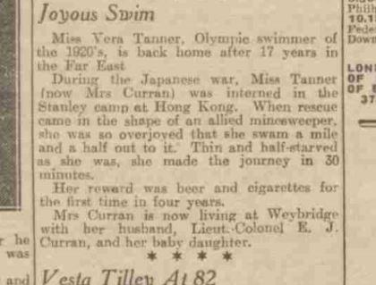
Dundee Evening Post courtesy William Long
The photograph below depicts the flag raising ceremony at Stanley Camp shortly after liberation. Vera would have been somewhere in the crowd of internees watching the flag raising, and soon she would be on her way home to England.

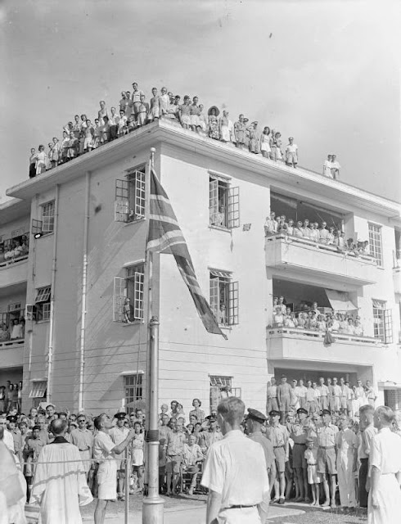
Liberation - hoisting the flag
Vera and Ned married on 29 March 1946. They had two children, Philippa and Bruce. Philippa tragically died in 1987 as a result of a brain tumour. Bruce a writer, sailor, traveller and adventurer lives in the Philippines and has helped me with photographs and information about his parents. After the war, Vera continued with her teaching career teaching at Farnborough Convent School. She died aged sixty-four in February 1971 at Alfriston in East Sussex. Ned passed away in 1989. Ned had a very tough time in the incredibly harsh and brutal conditions in POW Camps in Hong Kong and Japan. His son Bruce remembers his father telling him that on work parties from their camp in Japan - Japanese civilians mostly women would sometimes sidle up to the emaciated prisoners and surreptitiously pass them bits of food. Bruce has a vivid memory of watching the film - The Great Escape where Steve MacQueen well fed and fit escapes capture at least for a while on a motorbike.
My Dad got out of the chair behind me and said 'what a lot of piffle ! We did not even have enough energy to stand up to urinate when we were in prison with the Japs'.

Ned remained in the Army after the war. He retired after 35 years with the RAMC and was awarded the CBE, DSO and OBE for distinguished service.

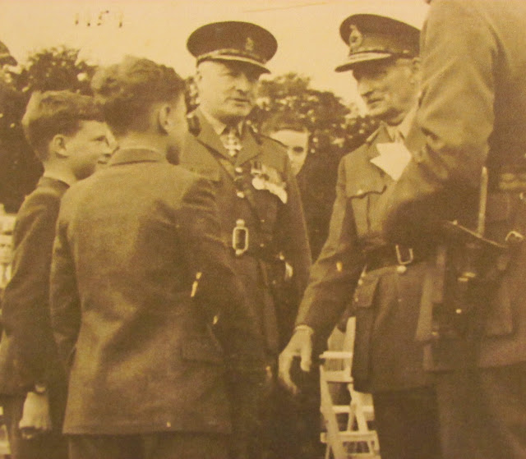
Brigadier Ned Curran presenting his son Bruce to Montgomery of Alamein in 1959 (Source: Bruce Curran)
Bruce has a photo (below) of Vera's swimming medals. Her proud husband had written on the back that these were Mum's medals taken by the Japanese when she was interned in Stanley Camp.
I wonder where they are now.
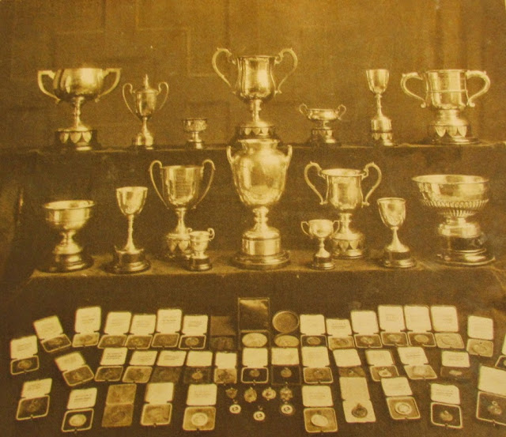
Vera's swimming medals lost to the Japanese or other looters during WW2 in Hong Kong (Bruce Curran)
An Olympic Games athlete - she went to Hong Kong looking for adventure and a new life - instead she found herself caught up in a brutal war - she found love again in a wartime romance - she survived the privations of a Japanese concentration camp - and finally, she made it home.
………………….
Acknowledgements

I was greatly helped in putting this story together by members of the family, in particular, Vera's daughter from her first marriage Julia Stevens who lives in South Africa and Julia's daughter in law Marianne Sanderson who I made contact with via Ancestry.com and who is researching her family history. I also received great help from Vera and Ned's son Bruce Curran who lives in the Philipines. After publication, I was contacted by William Long who was researching swimming history in Sussex and by Kobe's Scheepers who is researching swimming history in South Africa.

Sources:

1. Private Papers including War Diary of Capt. Peter Belton held at IWM
2. Tony Banham's Web Site www.hongkongwardiary.com
3. Shackleton's Diary for 19/12
4. Shackleton's Diary 28/12.
5. Tony Banham's Web Site www.hongkongwardiary.com
6. Barbara Redwood's Diary held at IWM
7. Franklin Gimson's Diary May 1944 (Held at HK University Special Collections)
8. Courtesy Marianne Sanderson & the Murrell family
9. Source: Tony Banham - "We Shall Suffer There" (2009)
10. Photographs of Emaciated Internees & Liberation courtesy Harold Thomas Matches Collection (HKU Special Collections)
11. Courtesy Bruce Curran
Addendum:
Message from Historian & Author Geoff Emerson to Marianne Sanderson:
Philip mentioned that Vera was in the same room as Elma Kelly. That rang a bell with me. I interviewed Elma twice way back in 1970! I searched my files and found the transcripts, and I think you'll enjoy reading what Elma said about Vera. Sadly, way back then I didn't take photos of the people I interviewed, but I recall that Elma was a very outspoken, opinionated business-woman, great fun to talk with.
Interview 26 June 1970 - Elma said that Vera was an Englishwoman married to a man in South Africa. She'd fallen out of love with him and came here (HK) for a holiday. One man said she came looking for romance. She got it, with an officer in the army medical corps, who fell for her. They married after the war.
There was insufficient water to run lavatories in St Stephen's Block 10, so a trench was dug outside...bad because everyone could see. Vera and Elma got up at 5 a.m. to "spend a large penny in this trench".
Vera was friendly with Gimson (Colonial Secretary) and played bridge with Elma and Gimson.
Interview 28 May 1970 - According to Elma, Vera Murrell used to sit on a little camp wooden box, very uncomfortable without a cushion, so she put Elma's cushion on it. Vera felt lumps and put her hand in the cushion and discovered money. Elma said "shhhh" and told her how she'd got this money from selling jewellery. They used the money (Japanese yen) for buying food."
Message from Marianne Sanderson to Geoff Emerson & Philip Cracknell
Hi Geoff and Philip,
Again, you have both added so much to the story of Vera - it really is coming together slowly but surely. Thank you both very, very much!
To add more information - Vera was employed as a teacher at Farnborough Convent (now called Farnborough Hill - address: Farnborough Hill, Farnborough, Hampshire, GU14 8AT) until 1969 (I am unsure when she started there as a teacher). She lived at Fairway Cottage, Brighton Lane, Seale, Surrey which is 13 miles away. So these facts correspond with what Elma told you way back in 1970. It sounds as if Vera and Elma may have kept in touch well after the war ended or heard about each other through the grapevine. In 1951 Vera and Ned Curran moved to Singapore from Scotland with their two young children. I only found this information yesterday on a ship's passenger list.
Vera's daughter, Julia, has told me the story of Vera selling her own jewellery for peanuts which Vera told her kept her alive. This may have been related to the jewellery that Elma sold.
The following information came from Vera's son, Bruce:
Vera apparently had a date with with Johnny Wiessmuller (Tarzan) during the 1924 Olympics, who himself got one world record there in Paris and two Olympic records also in swimming. Vera may have also gotten a Bronze medal in the freestyle individual event in 1924. Vera may have been 1 of 3 pacers in the first swim across the English Channel in 1926 by an American swimmer (referring to Gertrude Ederle who just two years later, at the 1924 Paris Olympics, won a gold medal in the 4 x 100 meter relay and a bronze in the 100- and 400-meter freestyle races so she likely knew of Vera). I believe she had a world record for a woman swimming 1 kilometre and 1 mile but have never been able to authenticate these. At aged 3 she swam a quarter of a mile in the sea in Eastbourne and won a big box of chocolates - while running home she ran round a corner into a fat man and the chocolates were scattered all over the road.
While in Stanley Camp the Americans bombed the camp unwittingly and 3 of her friends were killed by an American bomb. She is also in the HK history books, as you probably know, as she and a Police Sergeant swam out to meet the first warship that entered HK after the 2nd WW to relieve it from the Japanese occupation. The warship stopped and picked them up out of the shark infested waters.
My husband remembers that Vera came to South Africa (once alone and then again with Ned) around 1967 and then 1970".

https://olympics.com/en/athletes/vera-tanner
Vera Tanner showed great promise from the moment she won her first Junior Sussex title as 12-year-old in 1919. Every year between then and 1928, she won a Sussex title as either a junior or senior. As a 15-year-old in 1922, she won the junior and senior southern area 100 yards freestyle titles, both in record times. Tanner obtained her first ASA podium in 1923, finishing third in the 220 free. She was second in the 100 yards the following year and was a member of the British 4x100 metres freestyle silver medal-winning relay team, with Florence Barker, Connie Jeans and Grace McKenzie, at the 1924 Paris Olympics. One of the members of the winning USA team was Trudy Ederle, who Tanner accompanied on Ederle's unsuccessful attempt at swimming the English Channel in 1925.
Apart from finishing second in the ASA 440 yards and National Long-distance Championship in 1925, and the latter again in 1926, Tanner's career suffered a decline. With another Olympics looming, however, her form picked up, earning her a second Olympic selection, and she won yet another 4x100 free relay silver medal, this time with Joyce Cooper, Cissie Stewart and Ellen King. Tanner also reached the 400 free final, finishing sixth. She followed her Olympic appearance by springing a major surprise in beating Cooper and King to win the ASA 100 yards title shortly after the Amsterdam Games, and in record time. Tanner also finished second in the ASA 220 and 440 that year.
Tanner toured South Africa with a Great Britain ladies team in 1929 and re-met Dupre Murrell, who she originally met at the Paris Olympics, when he accompanied the South African men's team. Murrell and Tanner married in South Africa in April 1930 and she continued her career as a teacher at Grahamstown. She retired from swimming in 1934 but had taken up golf in 1931, and a little over two years later won the South African East Province Championship.
Tanner moved to Hong Kong in the late 1930s and worked for the Hong Kong Education Department. During the War, she enrolled as a nurse in the Auxiliary Nursing Service (ANS), and consequently missed the compulsory evacuation of women and children. She later became a Japanese prisoner-of-war, interned at the Stanley Camp in Hong Kong. She was released in 1945 and on return to England, married her second husband, lieutenant colonel Ned Curran.

