OLYMPIC SILVER TO DEAF SOUTH AFRICAN SWIMMER
by Stan Griffin, Deaf Friends International Special Contributor

"I think it will confirm that deaf people can do things." These were the words of Terence Parkin talking about his second-place finish in the Sydney Olympics 200-meter breaststroke final on September 20.
Asked about other effects of his performance, Parkin said, "Most deaf people in other countries know each other (and) ... know me. Not just athletes, it's beyond that ... (The deaf) help each other, and I hope this will help them."
Parkin has been swimming since the age of 12. Working with him has been his coach and friend, Graham Hill. During his career, Parkin earned distinction as his continent's fastest swimmer in the 200-meter breaststroke and the 400-meter individual medley. (Competitors in the medley must use four different strokes, one on each of the race's four legs: butterfly; backstroke; breaststroke, and freestyle).
Being deaf presents a problem at the beginning of each race when an electronic tone signals the official start. For a while, Hill would stand in Parkin's line of sight and signal him. They improved on that by using a light like a camera flash. Eventually they began using a strobe light, and this continues to work very efficiently. If there are swimmer introductions (as in most important races), Hill continues to cue him.
Parkin once used hearing aids when competing, but all the crowd noise disturbed him and made him nervous. He found it hard to "focus." Now, without the aids, there is a quiet atmosphere for the swimmer. Parkin is able to concentrate without audible interference and can think about his goals for the race.
 | 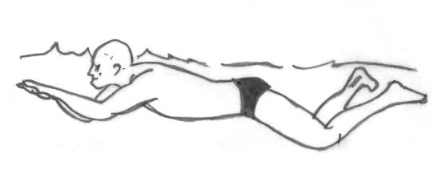 | 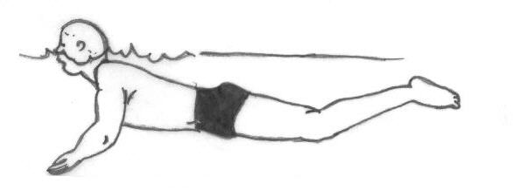

In Sydney, once he touched the pool's end on his final lap, Parkin looked up at the scoreboard to verify his finishing position. He saw a "2," but at first thought this was just his lane number. Soon it became clear that he had entered "silver country." He clenched his fists, "punched the sky," and then draped South Africa's flag around his shoulders. Parkin's grin stretched from ear to ear.
On the day after his medal-winning race, Parkin and Hill were guests of the South African Club at Sydney's Darling Harbor. Crowds of spectators gathered to see them. As Parkin moved around the room accepting congratulations, some of the people shook his hand while others thumped him on the back.
During a live interview broadcast to South Africa, Parkin expressed the hope he could inspire athletes from smaller countries to win medals.
Even in the midst of such a joyful celebration, Parkin was brought back to earth by the words of a well-meaning but thoughtless South African official to his audience: "Can you imagine without that handicap of his how great he would be?" Parkin would disagree, believing that he actually holds an advantage in the pool since he is "capable of everything but hearing."
Parkin spent a sleepless night before his big race. On the night after, though, he slept well--he had his medal to keep him company!
http://www.workersforjesus.com/dfi/857.htm

