Clayton Jimmie
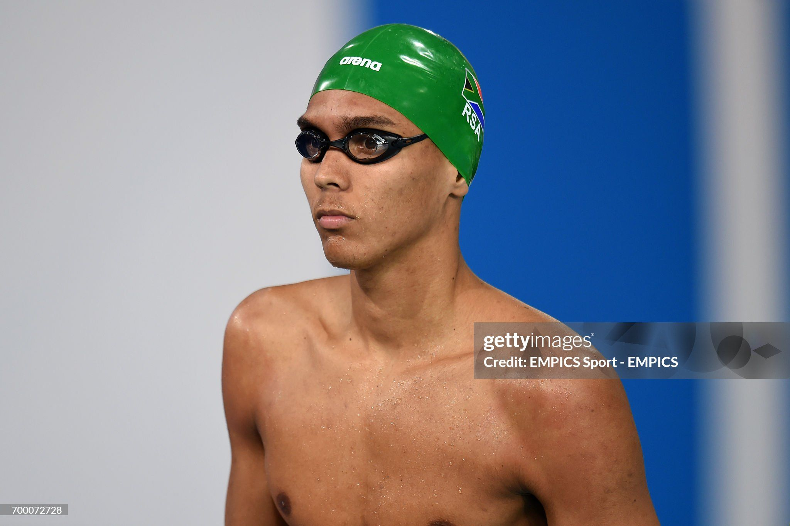
Clayton Jimmie was born in Durban on 10 July 1995. He attended Westville BHS where he swam with coach Graham Hill.
2014 Commonwealth Games in Scotland, Clayton swam in the heats of the 4x100 freestyle relay, in which South Africa won a bronze medal in the final. He achieved the same in the medley relay, where his team finished third, winning a bronze medal.
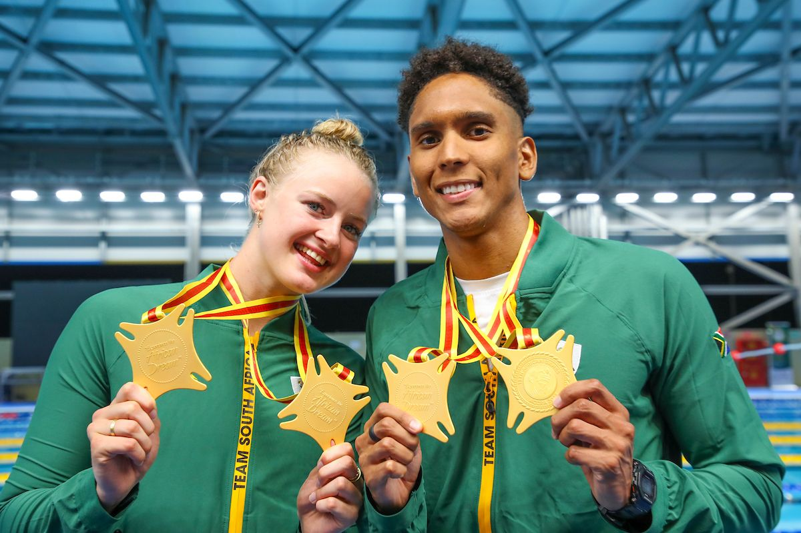
09 March 2024, Caitlyn de Lange and Clayton Jimmie of Team South Africa with their gold medals after the swimming finals at the Borteyman Aquatic Centre during day 3 of the 13th African Games in Ghana.
Personal best times
Event | Course | Time | Pts. | Date | City (Nation) | Meet
50m Freestyle | 50m | 22.33 | 821 | 16 Feb 2024 | Doha (QAT) | World Aquatics Championships
50m Freestyle | 25m | 21.84 | 786 | 15 Dec 2022 | Melbourne (AUS) | FINA: 16th World Short Course ...
100m Freestyle | 50m | 49.29 | 859 | 9 Mar 2024 | Accra (GHA) | 13. African Games
100m Freestyle | 25m | 48.09 | 810 | 14 Dec 2022 | Melbourne (AUS) | FINA: 16th World Short Course ...
50m Backstroke | 50m | 25.75 | 764 | 22 Aug 2022 | Tunis (TUN) | XV CANA African Championships
50m Backstroke | 25m | 24.85 | 704 | 22 Oct 2022 | Berlin (GER) | FINA: World Cup No 1 - 2022 Series
100m Backstroke | 50m | 57.62 | 718 | 18 Apr 2015 | Durban | South African Championships
50m Butterfly | 50m | 23.54 | 846 | 21 Aug 2022 | Tunis (TUN) | XV CANA African Championships
50m Butterfly | 25m | 23.41 | 801 | 13 Dec 2022 | Melbourne (AUS) | FINA: 16th World Short Course ...
100m Butterfly | 50m | 53.99 | 768 | 22 Aug 2022 | Tunis (TUN) | XV CANA African Championships
100m Butterfly | 25m | 54.28 | 682 | 21 Oct 2022 | Berlin (GER) | FINA: World Cup No 1 - 2022 Series
100m Medley | 25m | 57.44 | 631 | 8 Aug 2014 | Durban | South African Short Course ...
50m Freestyle Lap | 50m | 22.54 | - | 17 Apr 2015 | Durban | South African Championships
50m Freestyle Lap | 25m | 21.98 | - | 8 Aug 2014 | Durban | South African Short Course ...
100m Freestyle Lap | 50m | 49.17 | - | 18 Feb 2024 | Doha (QAT) | World Aquatics Championships
100m Freestyle Lap | 25m | 47.89 | - | 3 Dec 2014 | Doha (QAT) | FINA: 12th World Short Course ...
50m Butterfly Lap | 25m | 22.92 | - | 4 Dec 2014 | Doha (QAT) | FINA: 12th World Short Course ...
100m Butterfly Lap | 25m | 53.11 | - | 7 Dec 2014 | Doha (QAT) | FINA: 12th World Short Course ...
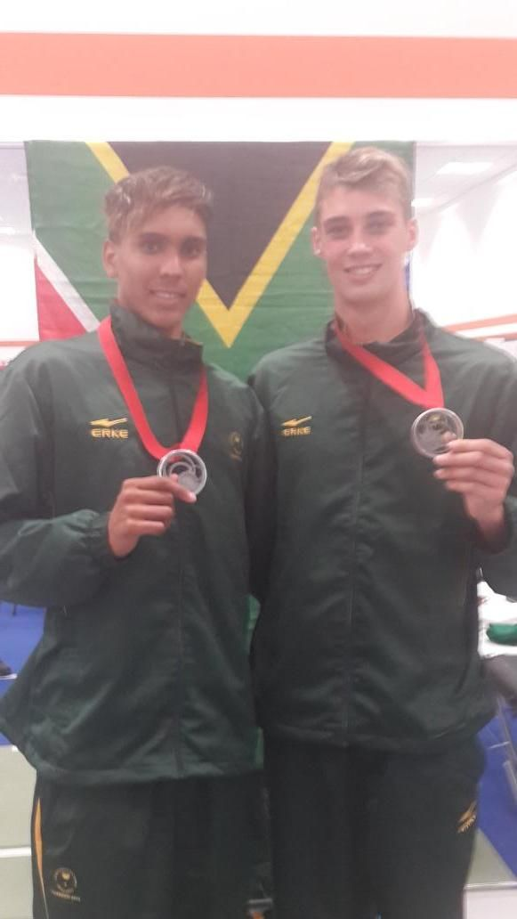
July 2014 - Clayton Jimmie and Calvyn Justus.

Westville Boys’ High rewrites record books and claims its 6th consecutive D + D Gala victory
South Africa’s top swimming school stamped its authority yet again on the swimming scene by winning its 6th consecutive Durban and Districts Boys A League Gala.
Although their victory on Wednesday night was not as emphatic as it was last year when their team won every single race, it was still emphatic enough to send out a clear message to the other schools that Westville’s reign as masters of the pool is far from over.
On the evening their under 15A, under 17A and under 19 A teams won all their races, fifteen in all.
Their under 16A team came unstuck in the Breastroke where they were just edged out by Glenwood and in the Butterfly which saw Clifton win by splits of a second.
Westville’s Under 14 A side which had made considerable inroads into Glenwood’s dominance during the swimming season, had to settle for 3rd places throughout the evening as a result of the unavailability of one of their top swimmers due to injury. Glenwood claimed 4 of the 5 races with Kearney’s under 14s showing good form to edge Glenwood out in the Butterfly to claim first place.
Westville’s under 19A side needs special mention. The team which consisted of Clayton Jimmie(Captain), Calvyn Justus, Lee Geeson, Alan Neat , Paul van Actherbergh and Rubin Terblanche pulverised the opposition in every race. They also demolished the five existing records set by Kearsney’s in 2011. It is a certainty that it will take a team of swimmers of exceptional ability to break these records and surpass the achievements of the WBHS under 19 superteam of 2013!
At the end of the gala, the Westville A team had still managed to win a formidable 19 of the 26 races.
Westville ‘s dominance at the D+D over the last six years is reflected in the fact that they now hold 25 of the 26 records –this is no small feat considering that the gala dates back to 1970!
Westville’s swimming depth is also reflected in the fact that their B team finished 5th overall. Special credit must be given to them for finishing ahead of the A teams from DHS and Northwood. Both these schools have a proud swimming history and are past winners of the D+D gala.
Now that the boys high schools swimming season is over, it is worth noting that Westville’s A team has remained undefeated, winning every major gala in the country for the 6th consecutive year. It has now won 46 galas in a row!
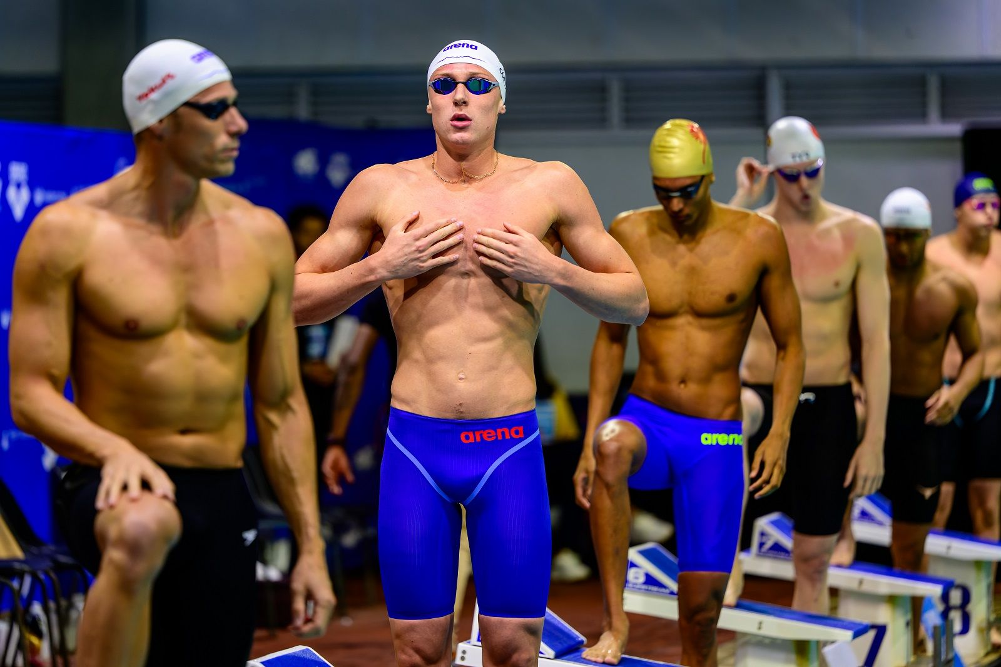
The final day of the 2024 South African National Championships unfolded from Gqeberha with 19-year-old Pieter Coetze capturing a fifth gold to conclude his campaign. 42-year-old Olympic medalist Roland Schoeman (left), Pieter and Clayton Jimmie (right).
The teen touched in 22.45 followed by Clayton Jimmie who hit 22.83 as the silver medalist.

